Corrugated Style File Maintenance 2/16/07

- From the main menu go to E-B-2 to build or change Corrugated Styles:

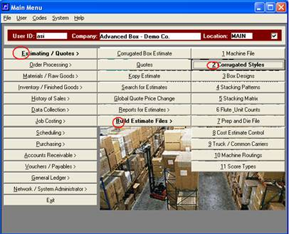

- Look up the style by style code or style description.

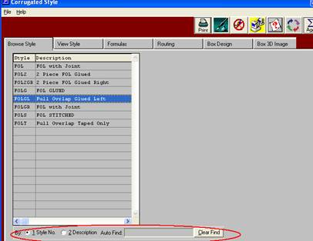

- Select the View Style tab and use the arrow keys to move to the desired flute for this style. Then hit the Update button to edit the data. (Or the Add button if you were creating a new style. Typically a user would use the Copy button to create a new style, changing only what was different, since it would save numerous keystrokes).

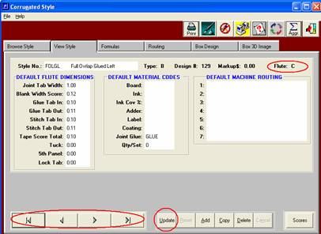

- In update mode you can modify the style. Go to the Joint Tab Width field to change the tab size (corrugated is defaulted to decimal 16th’s, so 1.08 is a 1 ½ inch tab). When you place the cursor in the Blank Width Score field a screen pops up that allows you to input (or override) your scoring for the blank width. If you want to include a specific scoring profile you van also put in a “type” in the field next to the panel size on the pop up (an F1 in this field will bring up the potential values). Once you change the scoring on hit the Save button on this pop up screen. The next panel (Glue Tab In) scoring pop up will immediately appear for you to potentially modify.

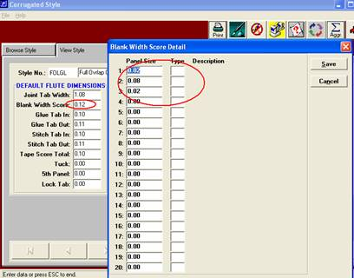

- Once you have updated the scoring for all panel for this style, hit the Save button on the bottom of the screen to save your changes.
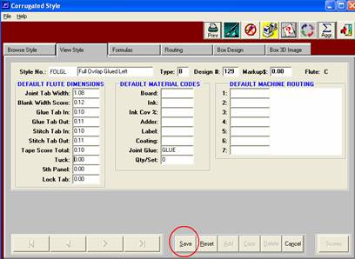

- You would need to repeat this process for each flute within this style. It may be easier to start with your RSC scoring, and then use the Scores button on the bottom of the screen to copy these scores to other box styles. For example, you may want to set adjust the scoring for all tab and panel configurations of how you may run an RSC (Tab-L-W-L-W, Tab-W-L-W-L, L-W-L-W-Tab and W-L-W-L-Tab) and then use the Score button to move the scores to another style (such as an HSC). Of course you would still need to go to the HSC style and adjust the Width scores since there is one less width panel.
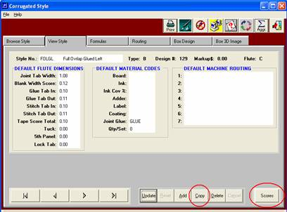

- The formula tab indicates the sequence of inside dimensions across the length and width panels. The “s” at the end of the formula is simply a flag to tell the program that there are no additional dimensions to follow. The Square feet panel data is typically the same as the layout formula. The KDF (knocked down flat) dimensions are used for palletization calculation, so they reflect the folded blank size. To change the formulas you would fit the Update button on the bottom of the screen. When you save this screen it will update the new formulas to all flutes within this style. If you needed to change the panel configurations for this style (for example, if your FOL length was J+W+L+W+L) then you would change the formulas on this page to reflect that.

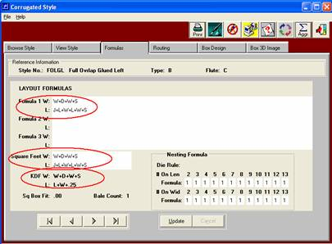

- The Routing tab is used to establish defaulted routing. This feature is optional, but the benefit is that the defaulted routing will then automatically be used when estimating this style of carton. To use this feature you would need to first have to build a listing of all potential routings in the routing table. (E-B-10).
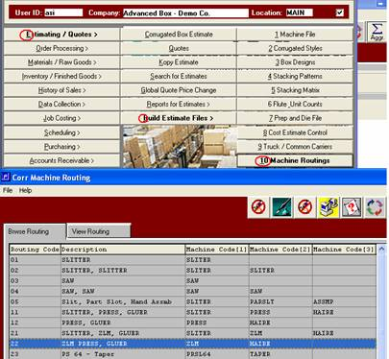

9. In the following example, there are established routing criteria based upon the total MSF being estimated (up to MSF) and blank size of the carton. As you can see, different routing combinations are then defaulted based upon the blank length and width. Each number in this matrix represents a potential routing sequence from the routing file (E-B-10) above. Therefore, it is critical to know the machine min and max sizes for each machine in the potential route so that it can be place in the appropriate up to length and width position in the matrix on the style routing tab. As an example, routing 21 is “Slitter, ZLM, Gluer” as can be seen in the screen capture above. The slitter was included since this routing is for orders up to 3 MSF (you can have different routing for any MSF break desired). Different routings are suggested at different intersection blank widths and widths (based on the machine limits). Routing 99 says “Buy outside” since there are no machines in my company that will run these intersecting blank sizes. We suggest that you build routing for one carton style (such as an RSC) and then use the copy button to copy this routing to other carton styles (FOL, HSC).
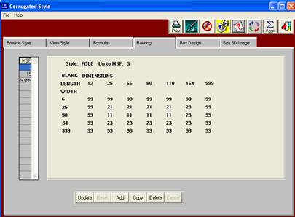

10. The box drawing that is associated with the style is visible from the Box Design tab. If you have changed the formulas to reflect different panel configurations (for example form W-L vs L-W) you will need to associate a different design number to associate with this style.
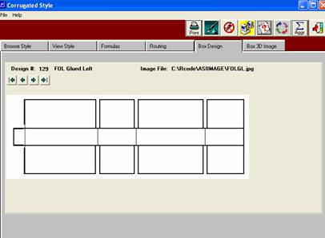

- The design number can be changed on the View Style tab. But before changing it, let’s discuss what drawing is attached to each design number. From the main menu go to E-B-3, Box Designs.

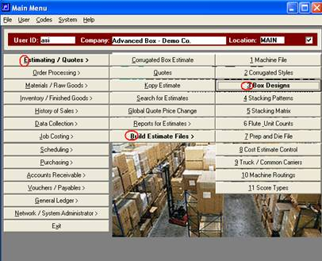

- In Box Design select the design number that was related to the style you were working on. You can then view, and / or associate a different box drawing if necessary, or add a new design number if desired.

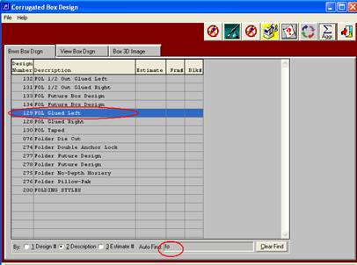

- On the View Box Design tab you will see the associated drawing for the selected design number. In update mode you can position your cursor in the Image File field and lookup all of the available images to associate with this box design.
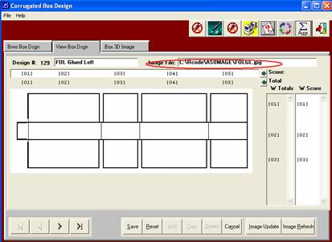

- To view other potential box drawings select F1 while your cursor is in the Image File field. We would suggest that you view the box images as thumbnail images so that you can easily associate a new drawing if you so desire. At this point you can either associate the new image with this design number, or you can add a new design number and attach a new drawing to it. If you change the drawing then the design number will remain the same in your style file.
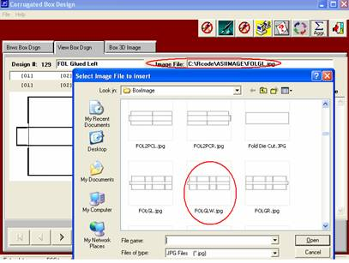

- You can also go to Windows explorer for the directory listed in the design file:

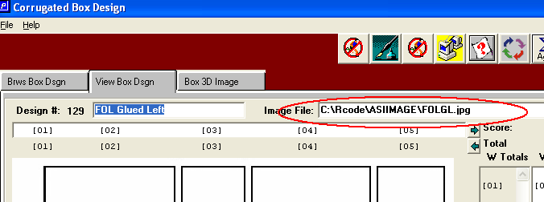

… and then select a design, double click it, and modify it with your JPG editor (usually MS Paint) and save it. You could also create a new design and save it to this same directory.

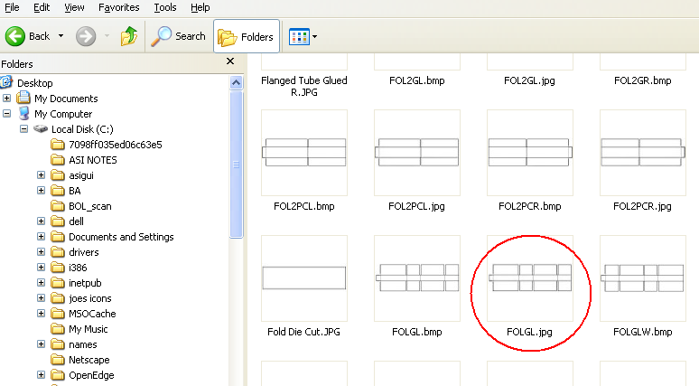

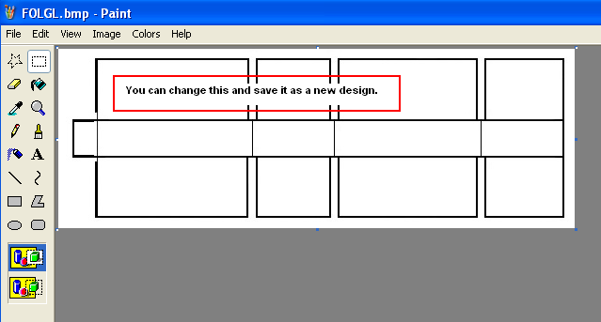

- You can also change the 3-D image associated with this box design by following the same procedure on the Box 3D Image Tab.
